Requirements Elicitation Report

Course/Module: [OOAD]

Name and Role of interviewee: [Leungo katlo Tebatso cse24-006]-SOFTWARE DEVELOPER

Name of interviewer: [Themba Moeng]

Date: [17/09/25]

# 1. Objective

The objective of this is to elicit and specify the system’s requirements in order to create a solid foundation for development. The focus is on identifying both functional and non-functional requirements of the proposed Banking System.

Functional Requirements- The following functional requirements were identified during the interview with the client:

1. **Customer Registration** – The system must allow new customers to register by providing personal details and creating an account.
2. **User Authentication** – The system must authenticate users (customers and staff) through login credentials before granting access.
3. **Account Management** – Customers must be able to view and manage their accounts (e.g., balance inquiry, account updates).
4. **Transaction Processing** – The system must support deposits, withdrawals, and fund transfers between accounts.
5. **Transaction History** – Customers must be able to view their past transactions for record-keeping.

Non-Functional Requirements -The following non-functional requirements were identified:

1. **Security** – The system must use encryption for sensitive data such as passwords and transactions.
2. **Performance** – The system should respond to user requests within 2–3 seconds.
3. **Usability** – The interface must be user-friendly, intuitive, and accessible to both technical and non-technical users.
4. **Scalability** – The system should support an increasing number of users and transactions without performance degradation.

| **Interview Question** | **Client’s Response** |
| --- | --- |

|  |  |
| --- | --- |
| Questions | Client Response |
| What basic details should be captured when registering a new customer | -Personal details, know the customer better where they live. |
| What type of transaction should the system support? | Deposit and withdrawal, so when they are performed you keep record or history of the events. |
| How should we calculate interest? And should it be credited monthly or yearly? | -goes through list of accounts first to see which one is due for adjacement in terms of balance. Taking balance, add it together and multiply by the % interest to get the total. |
| How should the system be designed and handle errors.  Should the system include everyone be it the staff of the organization | Have a pop up window that communicate  Capture both customers and staff regardless of whether they work for the organization or not. |

CLASS DIAGRAM

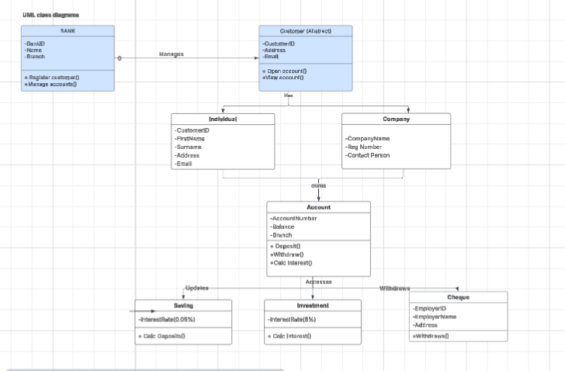

USE CASE DIAGRAM

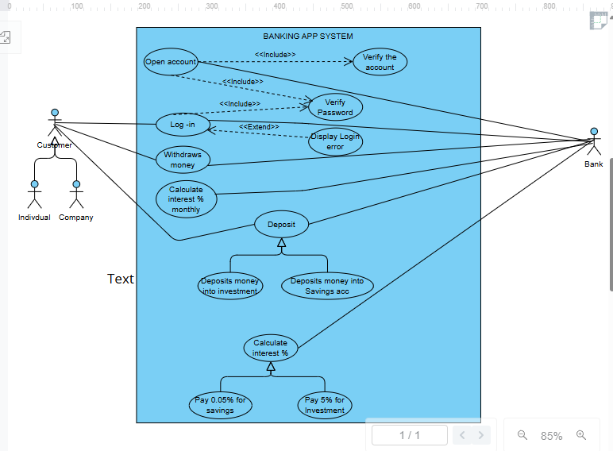

SEQUENCE DIAGRAM

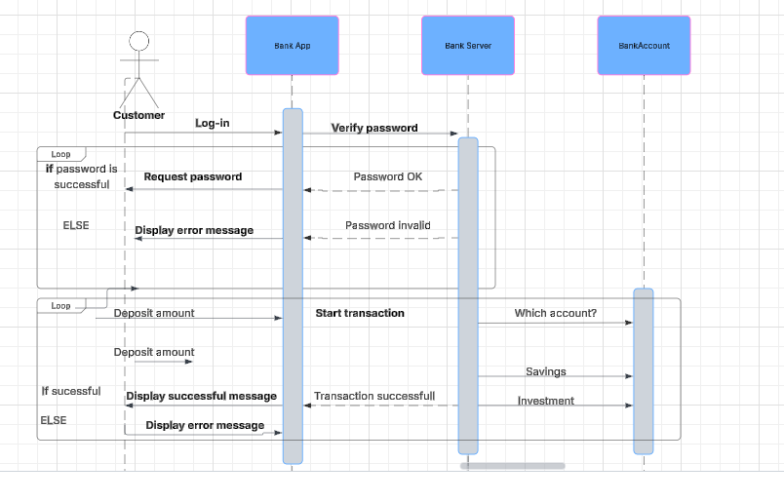

LOGIN-SEQUENCE DIAGRAM

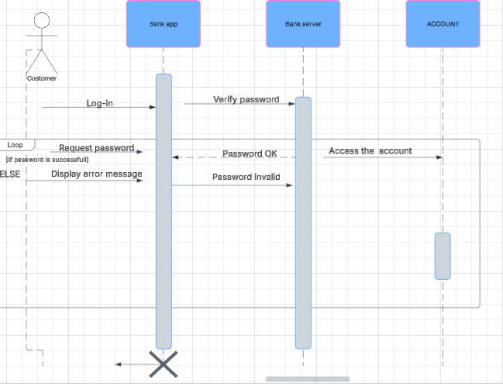

STATE DIAGRAM

